Dev Testing

Step 01: Data count in wincollect

Total Record count : 77465

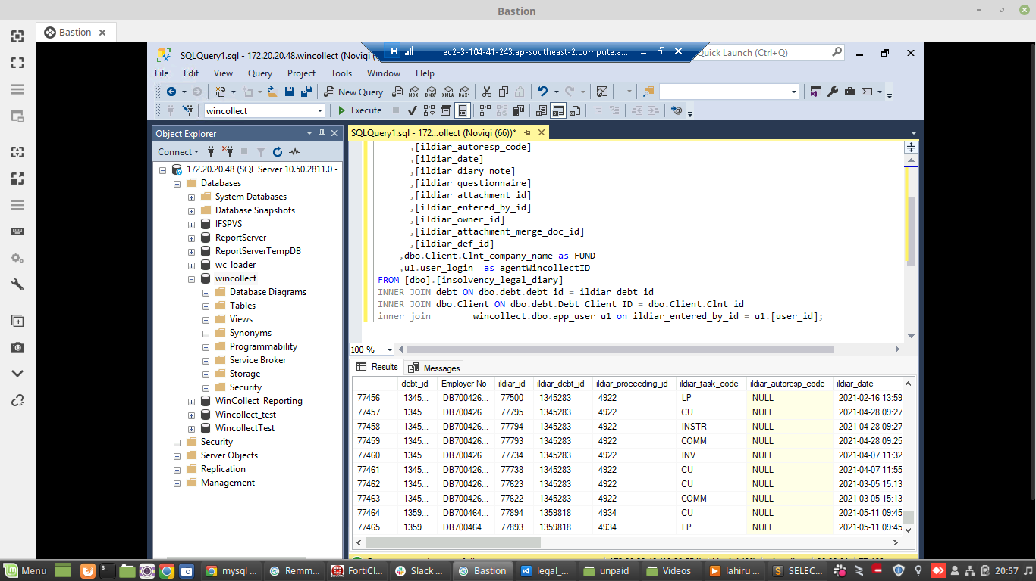
Step 02: Data count in S3 bucket (No way to look into this)

Step 03: Data count in particular Staging schema table in redshift (Record count : 77465)

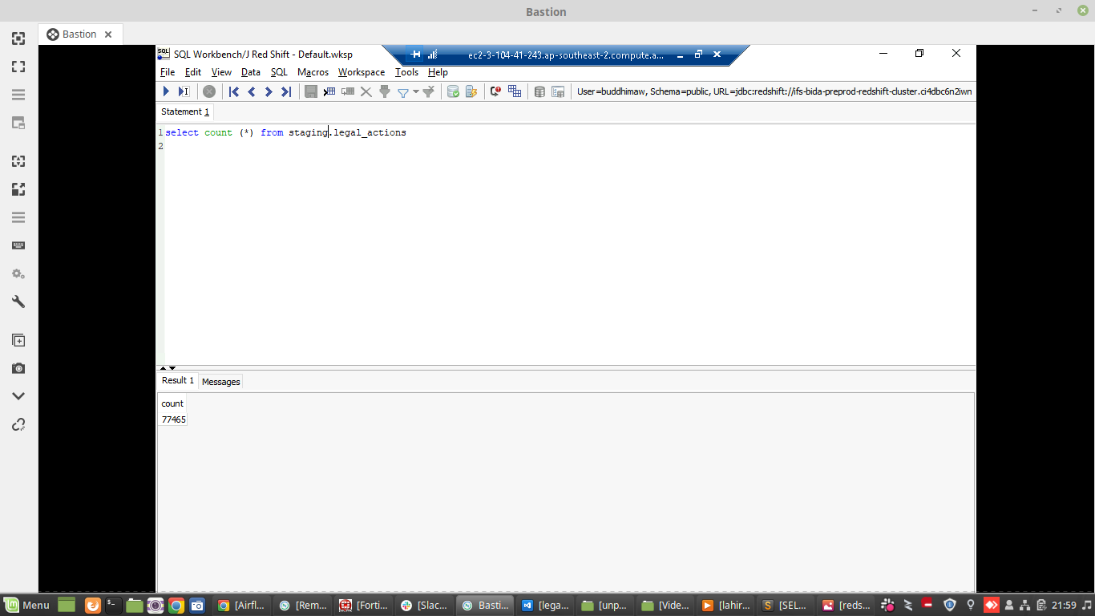
Step 04: Data count in particular Unpaid schema table in redshift (Record count : 77465)

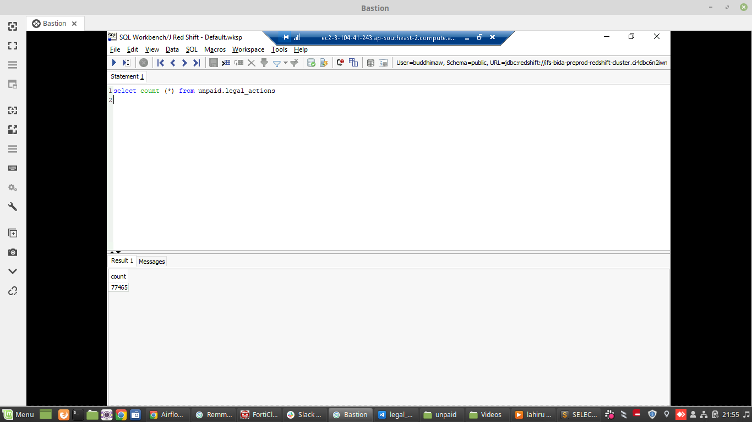

Air Flow UI

